We use Russian Longitudinal Monitoring Survey panel data. RLMS aim to monitor the effects of Russian reforms on the health and economic welfare of individuals in the Russian Federation. We use induvudual adult panel with post-stratification weights. With period of interest 2019 to 2020 we also included years from 2016 to 2022 to address parallel trends assumption.
Followings sample selection procedures were performend:
- Interviews from 4th anuual quaters were selected: this condition is based both on wave collection periods (usually September to January) and initial pandemic lockdown at the end of 2020.
- Only adults were selected.
- Individuals with extreme earnings were excluded: using calculated combied job income (formula ) we applied treshold at 95th percentile and excluded selected outliers.
- Only people present in 2019 and 2020 and employed at least in one of the periods were selected: that condition ensures that only employed at the period people were selected reflecting both possible job loss and gain and allows panel method application due to constant presence of stable units.
- Spillovers were excluded: people who acquired or lost disability status during period of interest were excluded due to violation of SUTVA requirements: control units may be affected by the treatment.
Selected panel data included following variables:
- Wage_j1 – after tax wages at the first job in last 30 days. This is a self reported variable in rubles that reflects wages earned at the first or only job of individual.
- Wage_j2 – after tax wages at the second job in last 30 days. This is a self reported variable in rubles that reflects wages earned at the second job of individual. Situations possible were first job earnings may be zero with real earnings from additional job.
- Income_iea – self reported additional paid work income in last 30 days. This variable reflects all income gained aside listed previously wages. It reflects all additional unofficial incomes received by individual for completed work (e. g. sevices of nurse, food delivery or repairing).
- Age – self reported number of full years by individual.
- Education_details – self reported level of education received by respondent over 14 years. It includes levels such as: years of school, scpecialized school, university etc. We choose to include university level only because of higher influence on outcome. Final variable is a dummy.
- Marital_status – self reported marital status with levels such as “married”, “never married” etc. The variable wes reduced to 1: “married”, “living together” and 0: “never married”, “divoresed”, “widow”. Final variable is a dummy.
- Gender – self reported gender. Transformed into a dummy with 1 = is_female.
- Harmful_work – reported danegrous, harmful or unhealthy conditions of workplace at job 1. Is a dummy variable.
- Current_work_status – self reported work status of the indivudual. It contains variables such as “you are currently working”, “you are not working”, “you are on paid leave” etc. The variable was transformed into dummy wariable 0 – not working and 1 – currently working.
- Has_disability – reported assigned disability class or abscence of it. We consider this variable objective because the unlike self reported health variables about indivudual’s faculties this variable was assigned by external organization and self report bias may be hidden only in reporting variable itself. The variable was transformend into a dummy with 1 standing for “has disability” and 0 otherwise. Cases of changing disability status were excluded at the period of interest.

Table ##. Continous variable descriptive weighted statistics.
Variable | Weighted \ Mean | Weighted \ STD
After tax wages at first job in last 30 days | 26659.08 | 19298.23
After tax wages at second job in last 30 days | 348.21 | 2779.33
Additional paid work income in last 30 days | 460.39 | 3520.9
Age | 42.62 | 12.17

Table ##. Binary variable descriptive weighted statistics.
Variable | weighted frequences
 | Var = 0 | Var = 1
Education details: University | 5899.47 | 3696.51
Marital status: Married | 2614.79 | 6981.19
Gender: Is female | 4766.761 | 4829.224
Harmful work: Yes | 8736.53 | 859.45
Current Work Status: Currently works | 857.26 | 8738.7
Has disability: Yes | 9802.07 | 222.89

Additional metric wages is calculated based on 3 main employment earnings (formula ):

$$wages= wage_{j1}+wage_{j2}+income_{iea}$$ | (3.1)
where:
- wage_{j1} – reported wages from first job,
- wage_{j2} – reported wages from second job,
- income_{iea} – reported additional earnings gained by paid labor.

This metric combines total employment earnings reflecting both official employment and unofficial sources of income. Additionally, this approach resolves situations with unpaid first jobs where individuals report zero received earnings
Picture ## shows timelapse of average wages for disabled and non-disabled groups. At the period of interest (2020) we observe a dip caused by pandemic. While it affected both groups altogether disabled people has suffered greater fall compared to control units.

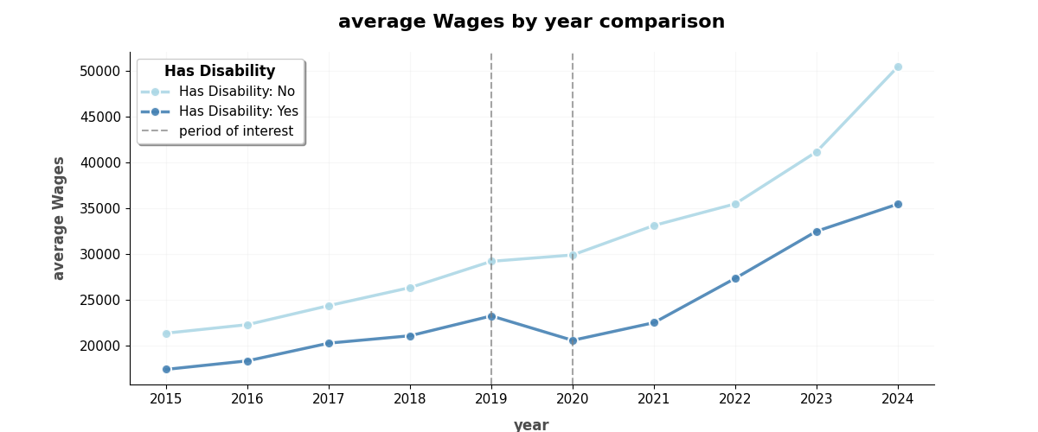
Picture ##. Timelapse comparison of average wages between control units (non-disabled people) to treatment units (disabled people)

2.3 Developing TWFE DiD model
As presented in the descriptive statistics (Table ##), the has_disability variable exhibits markedly disproportionate frequencies across comparison groups. This imbalance, coupled with the absence of random assignment – which is infeasible in disability research due to the inherent nature of disability status—poses a fundamental threat to valid causal inference in observational studies . Under non-randomized designs, treated and untreated units cannot be presumed comparable on pretreatment covariates, yet the validity of causal claims critically depends on such equivalence. To address these methodological challenges, we employ Propensity Score Matching. The propensity score, proposed by Rosenbaum and Rubin's seminal work, demonstrates that conditioning solely on this scalar propensity score suffices to eliminate bias attributable to all observed covariates, thereby approximating the conditions of a randomized experiment in observational studies .
We employed variables: age, education level, gender, harmful job and employment to match units properly. To address non-normality of age distribution we performend Box-Cox transformation on on the age variable with resulting $λ=0.303$. Variable Age_Box_Cox was calculated according to formula ##:

$$Age_{box-cox}= \frac{Age^{(λ-1)}}{λ} where λ=0.303$$ | (3.1)

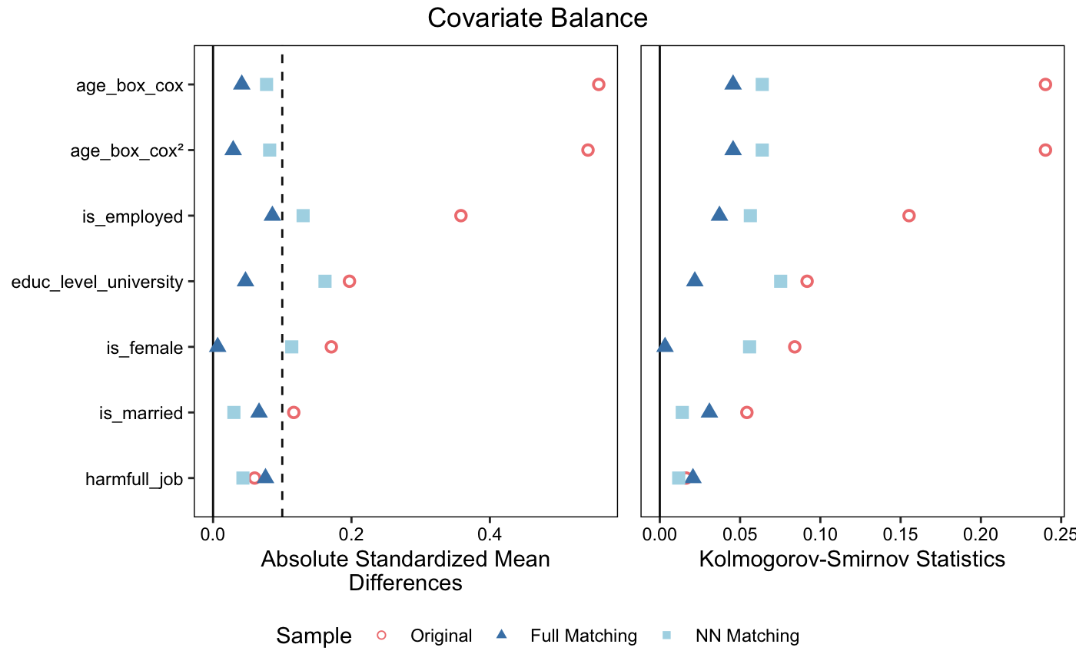
Picture ##. Covariate balance comparison between multiple psm approaches (distances reflected with ASMD and Kolmogorov-Smirnov metrics).

We performed several types of propensity score matching in order to identify the most appropriate for the case (Picture ##):
- nearest neighbor 1:1 matching without replacement with a propensity score estimated using logistic regression of the treatment on the covariates
- logit optimal full matching estimated with logistic regression.
Nearest-neighbor matching yielded poor balance as indicated in Picture ##. On the contrary ligit model has yielded adequate balance. The propensity score was estimated using a logit regression of the treatment on the covariates, which yielded better balance than did NN appriach. After matching, all standardized mean differences for the covariates were below 0.1 and all standardized mean differences for squares and two-way interactions between covariates were below .15, indicating adequate balance. Full matching uses all treated and all control units, so no units were discarded by the matching. Panel weights were applied to generate PSM weights. Tables ## and ## summarize balancing results of full ligit model approach. Low standardized mean differences and eCDF statistics indicate adequate balancing performend by PSM approach. As shown in table ## total of 221 of treated individuals were matched to 9309 of contol individuals.
Final PSM specification as following form (formula ##):

$$\log\left(\frac{P\left(disability=1\right)}{1-P\left(disability=1\right)}\right)=β_{0}+ β_{1}∙age_{box cox}+$$  $$β_{3}∙education:university+$$  $$β_{4}∙female+ β_{5}∙harmful job+ β_{6}∙employed$$ | (3.2)

where:
- disability: is outcome variable has_disability considered as a probability of the treatment. Social model of disability was elected in order to evaluate treatment probability as evironmental and social factors were considrered to be regressors.
- Age_box_cox: Box-Cox transformed Age variable using $λ=0.303$.
- education level: university: achieved education level: university.
- female: female gender of the respindent.
- harmful job: harmful environment exposure at working place.
- employed: employment status.

Table ##. Propensity score balancing results summary. Low eCDF and SMD indicate adequate balancing strategies
Variable | Means treated | Means control | Std, mean diff. | Var. Ratio | Ecdf mean | Ecdf max | Std. Pair dist.
Distance | 0,035 | 0,033 | 0,072 | 1,037 | 0,019 | 0,070 | 0,015
Age_{box-cox} | 7,358 | 7,323 | 0,042 | 0,817 | 0,015 | 0,046 | 0,861
Education:university | 0,317 | 0,339 | -0,047 |  | 0,022 | 0,022 | 0,921
Female | 0,410 | 0,407 | 0,007 |  | 0,003 | 0,003 | 0,756
Married | 0,683 | 0,652 | 0,066 |  | 0,031 | 0,031 | 0,908
Harmfull job | 0,081 | 0,102 | -0,076 |  | 0,021 | 0,021 | 0,523
Employed | 0,749 | 0,786 | -0,086 |  | 0,037 | 0,037 | 0,292

Table ##. Propensity score matching results summary. Total 9530 were matched.
 | control | treated
all (ESS) | 9177,95 | 215,6
all | 14595 | 325
matched (ESS) | 349,21 | 215,6
matched | 9309 | 221
unmatched | 5286 | 104
discarded | 0 | 0

Two way fixed effects OLS was performed with clustered standard errors at individual level. Clustering of the covariance was performed due to presence of significant serieal correlation with coefficient on lagged differences equals to -0,447 and z-statistic equals to -9,342 at 99% level of significance. Wooldridge's test was used for serial correlation in panel data (table ##). Serial correlation presence violates BLUE assumptions about ordinary least squares and thus must be eliminated by means of covariance type adjusting at individual level.
Following two way fixed effects (TWFE) specification is used:

$$wages_{it}= γ_{i}+λ_{t}+δ∙{disability_{it}×period}_{it}+ε_{it}$$ | (3.2)
where:
- $wages_{it}$ – computed aggregated job income for individual i in period t.
- ${disability_{it}×period}_{it}$ – treatment indicator of being disabled at period = 1 (the beginning of the pandemic).
- $δ$ – effect of being disabled at period = 1 (the beginning of the pandemic).
- $γ_{i}$ – unit specific fixed effects of being disabled.
- $λ_{t}$ – time-specific fixed effects of the pandemic.
- $ε_{it}$ – error term where $E\left[ε_{it}\right]=0$.

As indicated in table ##, the average marginal effect of having a disability on aggregated wages during the pandemic period is a statistically significant decline of -5,678.95 in monthly earnings compared to their pre-pandemic baseline relative to non-disabled workers (SE = 2,350.19, p = 0.016). The 95% confidence interval ranges from -10,287.58 to -1,070.32. This corresponds to approximately a 19% reduction relative to the pre-pandemic mean for this group.

Table ##. TWFE summary statistics.
variable | parameter | std. Err. | t-stat | p-value | upper CI | lower CI
has_disability × period | -5678,95* | 2350,19 | -2,41638 | 0,01575 | - 10287,58 | -1070,319

Num.Obs. | 4772
R2 | 0,659
R2 Adj. | 0,552
R2 Within | 0,007
R2 Within Adj. | 0,007
Fixed-effects | 2386
AIC | 222986,5
BIC | 240224,0
RMSE | 13835,63
Time Effects | True
Entity Effects | True
Covariance type | Clustered (ind)
. p < 0.1, * p < 0.05, ** p < 0.01, *** p < 0.001

Overall R² 0.659 indicates that the fixed effects alone absorb substantial cross-sectional variation in earnings.
Table ##. Wooldridge's test for serial correlation in panel data results.
variable | parameter | std. Err. | z | p-value | upper CI | lower CI
Intercept | 3335,742*** | 281,878 | 11,834 | 0,000 | 2783,272 | 3888,213
resid_diff_lag | -0,447*** | 0,048 | -9,342 | 0,000 | -0,541 | -0,353

Num.Obs. | 5188
R2 | 0,162
R2 Adj. | 0,161
AIC | 117201,014
BIC | 117214.1219
Covariance type | HC1
. p < 0.1, * p < 0.05, ** p < 0.01, *** p < 0.001

To address parallel trends assumption a dynamic TWFE model was computed with following specification:
$$wages_{it}= γ_{i}+λ_{t}+{\sum_{k=-l}^{m}{ }δ}_{k}∙{disability_{ki}×period}_{ki}+{β∙X}_{it}^{'}+ε_{it}$$ | (3.2)
where:
- $wages_{it}$ – computed aggregated job income for individual i in period t.
- ${disability_{ik}×period}_{ik}$ – treatment indicator of being disabled at period = k (the beginning of the pandemic).
- $δ_{k}$ – effect of being disabled at period = k .
- $l$ – the number of pre-treatment periods.
- $m$ – the number of post-treatment periods.
- $γ_{i}$ – unit specific fixed effects of being disabled.
- $λ_{t}$ – time-specific fixed effects of the pandemic.
- $ε_{it}$ – error term where $E\left[ε_{it}\right]=0$.

Table ## demonstrates no significant effects prior to the pandemic. Additionally, parameters comparatively close to zero indicating prominent parallel trends picture ##. Joined F-test for pretreatment period shows no significant statistic (table ##): F= 2.02319. p-value = 0.098783 with 1,603 DoF.
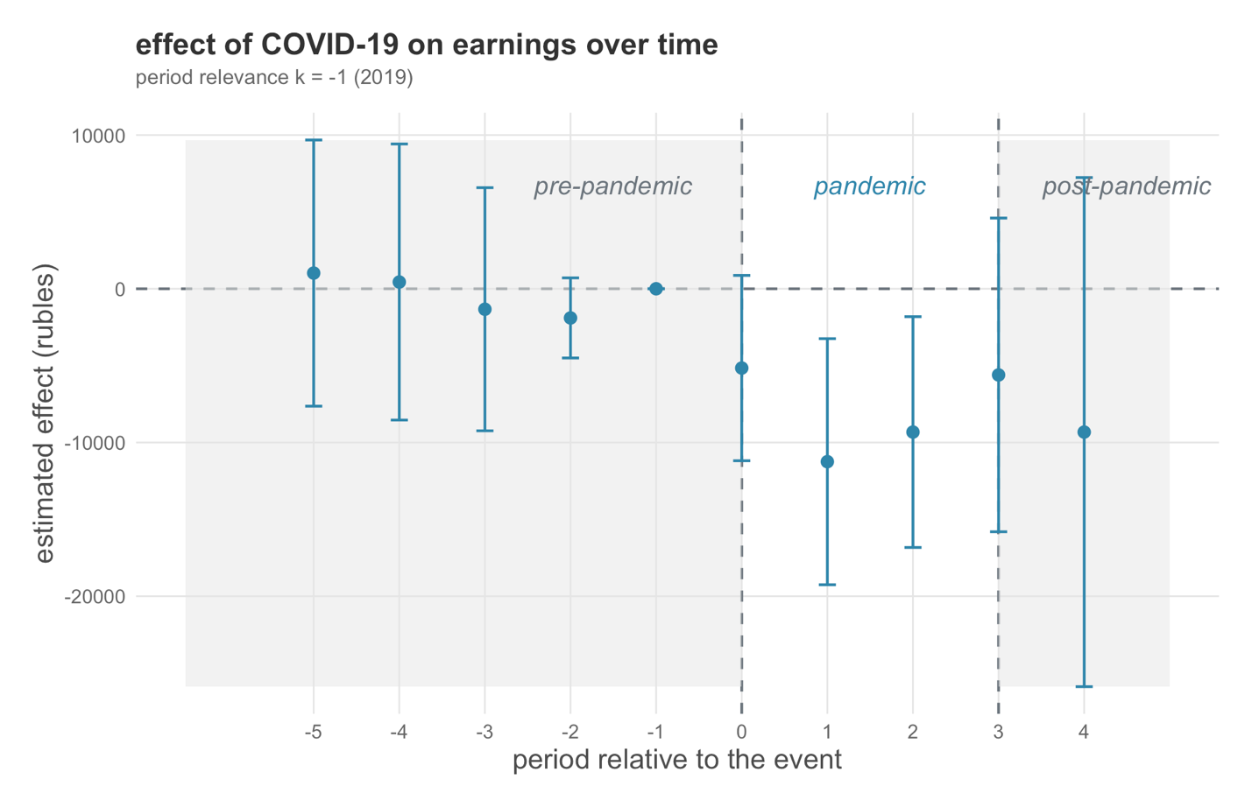
Picture ##. Coefficient plot of dynamic TWFE regression with hilighted pandemic period.
Table ##. Results of dynamic TWFE.
variable | parameter | std. Err. | t-stat | p-value | upper CI | lower CI
period_relevance = -5 × has_disability × period | 1020,673 | 947,342 | 1,0774 | 0,2814 | -4119,58 | 14160,93
period_relevance = -4 × has_disability × period | 437,918 | 4577,347 | 0,0956 | 0,9237 | -8540,3 | 9416,131
period_relevance = -3 × has_disability × period | -1332,546 | 4031,562 | -0,3305 | 0,7410 | -9240,23 | 6575,142
period_relevance = -2 × has_disability × period | -1899,068* | -839,064 | -2,2633 | 0,0237 | -11011,3 | -786,807
period_relevance = 0 × has_disability × period | -5158,921+ | 3073,242 | -1,67866 | 0,0934 | -11186,9 | 869,0732
period_relevance = 1 × has_disability × period | -11248,3** | 4080,274 | -2,75674 | 0,0059 | -19251,5 | -3245,03
period_relevance = 2 × has_disability × period | -9323,438* | 3827,022 | -2,43621 | 0,01495 | -16829,9 | -1816,94
period_relevance = 3 × has_disability × period | -5605,689 | 5201,050 | -1,0778 | 0,2812 | -15807,3 | 4595,885
period_relevance = 4 × has_disability × period | -9323,863 | 8146,257 | -1,10437 | 0,26959 | -25883,8 | 7236,054

Num.Obs. | 9431
R2 | 0,646
R2 Adj. | 0,572
R2 Within | 0,002
R2 Within Adj. | 0,001
Fixed-effects | 1604
AIC | 212586,5
BIC | 224186,7
RMSE | 15989,70
Time Effects | True
Entity Effects | True
Covariance type | Clustered (ind)
+ p < 0.1, * p < 0.05, ** p < 0.01, *** p < 0.001

